RAKHI

# OBJECTIVE

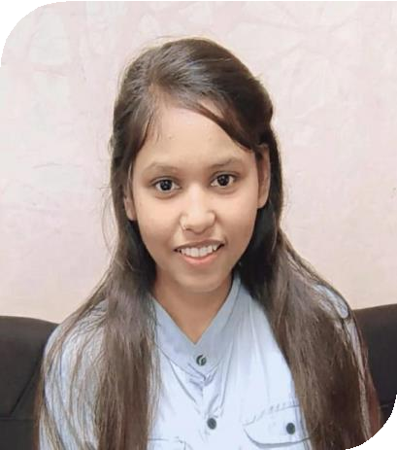

Looking for a challenging in a reputable organization to utilize my technical, database, and communication skills for the growth of the organization as well as to enhance my knowledge.

# CONTACT

PHONE:

9582627348

ADDRESS**:**

Shiv puri Vijay Nagar Ghaziabad,201009

GIT-HUB:

<https://github.com/rakhiprajapati042001>

LINKED-IN:

[http://linkedin.com/in/rakhi-prajapati-](http://linkedin.com/in/rakhi-prajapati-212289231) [212289231](http://linkedin.com/in/rakhi-prajapati-212289231)

EMAIL:

[rakhiprajapati042001@gmail.com](mailto:rakhiprajapati042001@gmail.com)

**HOBBIES**

Travelling Riding

Listing a Song

# EDUCATION

* (2019-2023): **Bachelor of Technology** from Dr.APJ Abdul Kalam Technical University, Lucknow with overall **77.97%.**
* (2018-2019): **Intermediate (PCM)** from Government Girls Inter College, UP Board with overall **74.2%**
* (2016-2017): **High School** from Government Girls Inter College, UP Board **with 69.1%.**

# TECHNICAL SKILL

* Language: Java, C, C++
* Database: SQL, DBMS
* Web Development: HTML, CSS, JavaScript

# ACHIEVEMENT

* Certificate Of Appreciation for Presenting **(MARICA -SOCIAL MEDIA APPLICATION) Projec**t by Sopra Steria Foundation.
* Active Participation and Scholar at Sopra Steria

# PROJECT

## To-do List

**Objective**-ľhe best way to oíganize youíself and youí woík

* **MARICA-**Social Media Application (Working)

# EXPERIENCES

* Sopra Steria India, Noida — As an Intern

## (July 2022 - August 2022)

Here I learn a java technology and also work on the personal To-do List Project.